Set Problem

Ace University had declared the end-semester exam results, after which, few students applied for re-evaluation of their answer scripts. The university rule is that a student can apply for re-evaluation only in one subject but some students applied for re-evaluation in more than one subject. Since the data was stored in a list, the management observed that the students were able to apply for re-evaluation in more than one subject and data was found to be redundant. The following is the subject-wise details of the students who applied for re-evaluation:

Subject: Compilers

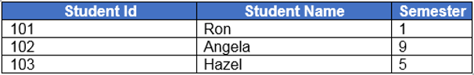

Subject: Algorithms

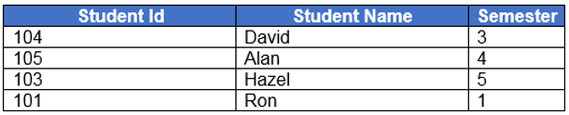

The class Student is partially implemented and provided to you. You need to complete the implementation of Student class.

Implement the following in the Tester class:

* Store the information about all the students in a list (List<Student>) who have applied for re-evaluation in all the subjects.
* Use a collection to eliminate the duplicates and store the data to provide appropriate information to the management. TreeSet<Student> can be used for this purpose.
* Display the details of the students who have applied for re-evaluation in increasing order of their studentId as follows:

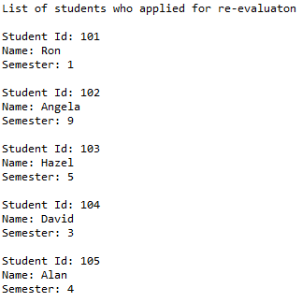

* Management wants to inform the students who have applied for re-evaluation in multiple subjects to choose only one subject. Display the details of those students who have applied for re-evaluation in more than one subject as follows:

